Document Report Designer (diagram)

Author: $Author

Publisher: $Publisher

Date: $date
The Document Report Designer diagram provides a convenient way to prepare simple structure of Microsoft Word document template (DOCX), as shown in the following steps.

Create your Document Report Designer diagram
Create a new Document Report Designer diagram in the Report Designer Diagrams category.
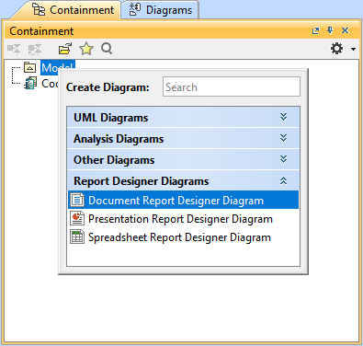

You will get the empty Document Report Designer diagram.
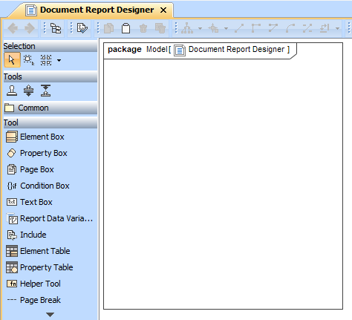

Start with Text Box
Click the Text Box button on the toolbar and drag it to the diagram. Type static text or Velocity code in the box as desired.
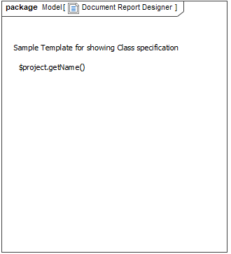

Print Class elements
Click the Element Box button on the toolbar and drag it to the diagram. The Select Element dialog will open. Select the Class element in your project.
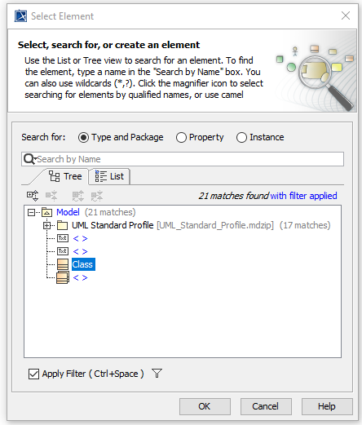

You will get the \#foreach directive for printing all Class elements in your project.

Print Class name and list properties
Create Property Box in Element Box to list properties of Class. Type name in the search box and select it from the list shown up.
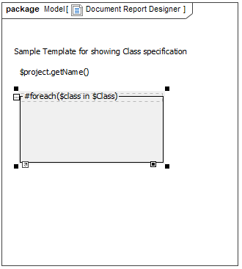
You will get a box for printing the Class name.
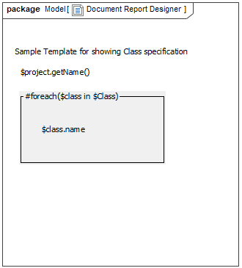

Create another Property Box for the member property returning a collection so that you will get its items in the \#foreach directive.
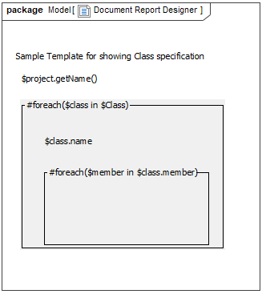

Create static Member: Text Box before the \#foreach directive of \$class.member and create dynamic \$member.name Text Box in the \#foreach directive of \$class.member.
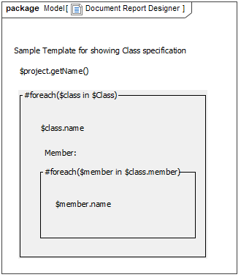
Note: You can create Property Box only in Element Box and Page Box.

Define condition statements
Click the Condition Box button on the toolbar and drag it to the diagram for classifying a Class name.
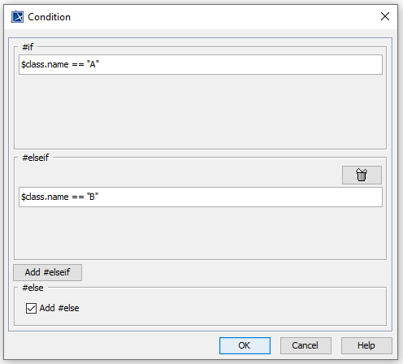
Then, create Text Box for each condition.
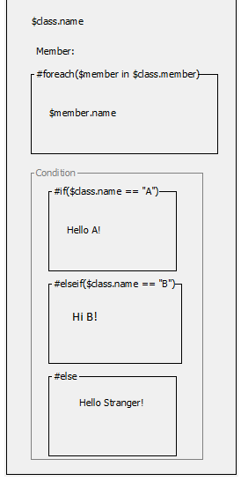

Print value from Report Data Variable
Click the Report Data Variable button on the toolbar and drag it to the diagram to create your Report Data and its Variable. In the open Report Data Variable dialog, select Report Data and Variable, e.g., author.
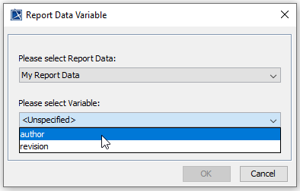
The \$author variable will be created. You can add more text before the Variable name, e.g., Created By: \$author.
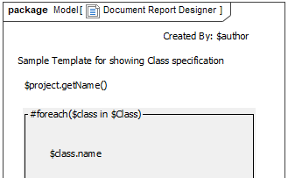

Print a property item into a table
Click the Property Table button on the toolbar and drag it to the diagram to create Property Table in Element Box or Page Box so that the property of element scope will be listed, similar to Property Box.
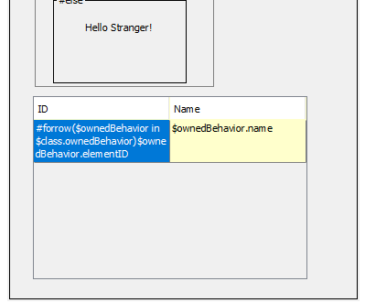

Include content from another document
Click the Include button on the toolbar and drag it to the diagram to create the Include element. If you want to use the include() function, you can specify only a document file or the Attached File element without having to enter a section name.
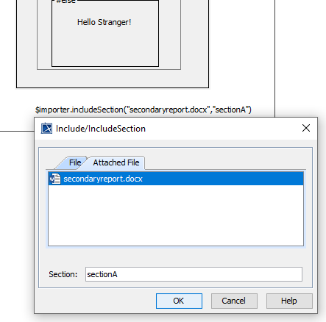

Create a link
You can create a link by using the Helper Tool element where you can find more utilized functions. Click the Helper Tool button on the toolbar and drag it to the diagram to create it. In the open Helper Tool dialog, select Create hyperlink by specifying URL.

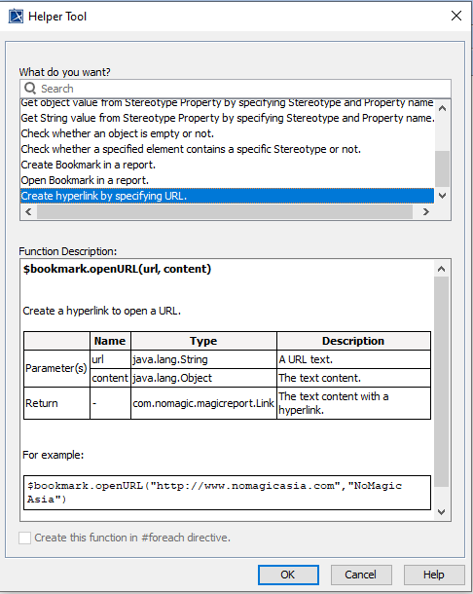

You will have the parameters in \$bookmark.openURL(url, content) updated to \$bookmark.openURL(“www.nomagic.com”,“NoMagic”).

Add Page Break after the first template segment
You can start a new page by adding the Page Break element. Click the Page Break button on the toolbar and drag it to the diagram to create it.
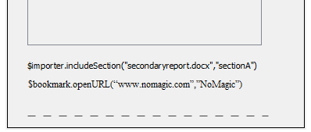

Print a new segment starting with a new page
You can start a new page for every element in a collection by using the \#forpage directive created in Page Box as well as Element Box.
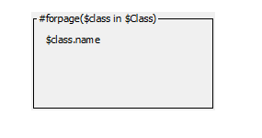

Print Element in a table
You can list all elements in a table by using Element Table. Click the Element Table button on the toolbar and drag it to the diagram to create it.
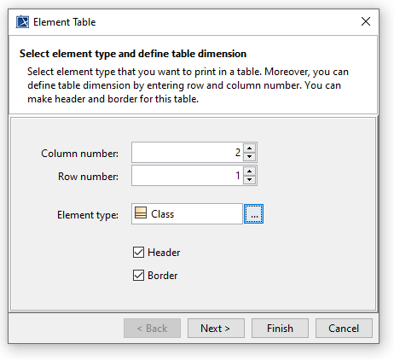

Define column and row numbers, as well as element type of the table context. Moreover, you can define header and border of the table in a template.

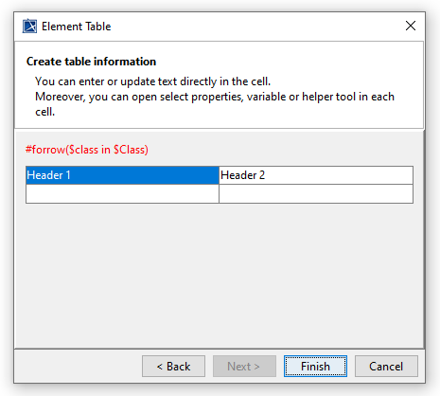
For next step, you can update header and table cell directly in UI. You can press Ctrl+Space to see element’s properties guide that you can print in the table.

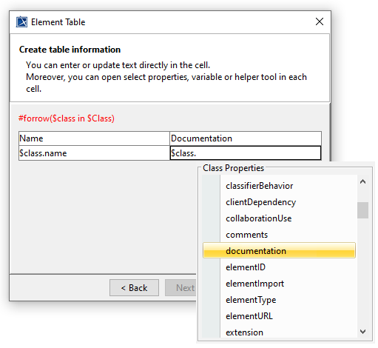

Each element will be printed in a row using the \#forrow directive.
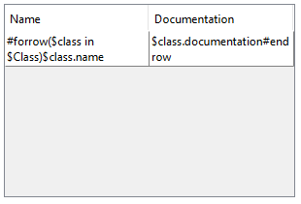

Print property of element in table form
In \#foreach statement for printing element, you can print property of element in table. Click the Property Table button on the toolbar and drag it to the diagram to create it. Property A Table which has same use cases with Element Table will be opened. You can update the table cell content and use element’s properties guide same as Property Table dialog.

Generate DOCX template from the Document Report Designer diagram

Here is the complete Document Report Designer diagram.
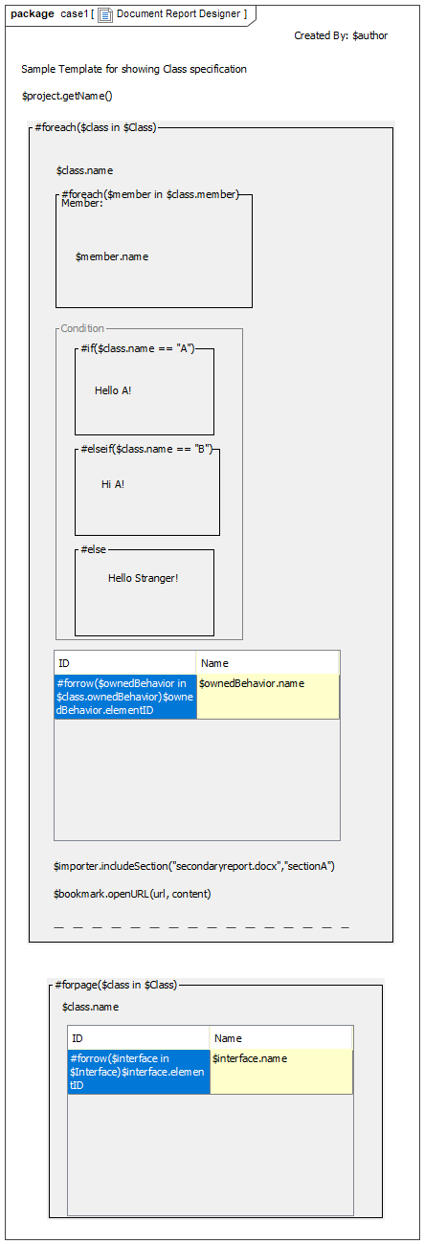

You can start to generate the template by right-clicking Document Report Designer in the Containment tree and selecting Generate Template > DOCX Template.
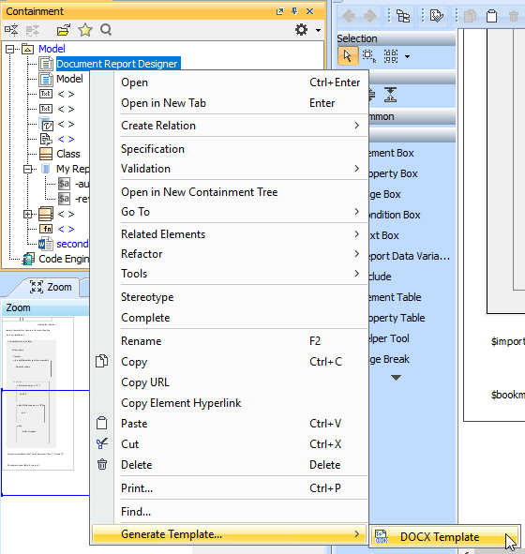

Here is the complete template you can refine more code logic and apply font styles in Microsoft Word.
\#import("importer", "com.nomagic.reportwizard.tools.ImportTool")
Created By: \$author
Sample Template for showing Class specification
\$project.getName()
\#foreach(\$class in \$Class)
\$class.name
\#foreach(\$member in \$class.member)
\$member.name
\#end
Member:
\#if(\$class.name == "A")
Hello A!
\#elseif(\$class.name == "B")
Hi A!
\#else
Hello Stranger!
\#end
ID | Name
\#forrow(\$ownedBehavior in \$class.ownedBehavior)\$ownedBehavior.elementID | \$ownedBehavior.name\#endrow
\$importer.includeSection("secondaryreport.docx","sectionA")
\$bookmark.openURL(“www.nomagic.com,“NoMagic”)

\#end
\#forpage(\$class in \$Class)
\$class.name
ID | Name
\#forrow(\$interface in \$Interface)\$interface.elementID | \$interface.name\#endrow
\#endpage

